**Experiment No.10: Mobile Node Discovery**

|  |  |  |  |
| --- | --- | --- | --- |
| **Roll No: 113** | **Name: Harshita Shetty** | **Div: B** | **Batch: B2** |

**Aim:** To Implement the Mobile Node Discovery Using Python.

**Theory:** Mobile Node Discovery is a process by which a mobile device or node (such as a smartphone or tablet) can discover and connect to other nodes or devices on a network, typically a wireless network such as Wi-Fi or Bluetooth. The discovery process is necessary for enabling communication and data exchange between mobile devices and other nodes on the network. The mobile node discovery process typically involves two main components: scanning an advertisement. Scanning is the process by which a mobile device searches for other nodes or devices that are advertising its presence on the network. This is typically done by sending out broadcast messages and listening for responses from other devices.

Advertisement is the process by which nodes or devices on the network advertise their presence to other devices. This is typically done by broadcasting messages or signals that contain information about the device, such as its unique identifier (such as a MAC address) or the services it provides.

Once a mobile device has discovered another node or device on the network, it can establish a connection and begin exchanging data. This may involve establishing a direct connection between the two devices or connecting through an intermediate node, such as a router or access point.

Mobile Node Discovery is an important process for enabling mobile devices to communicate and collaborate with other devices on a network. It is used in a wide range of applications, from file sharing and messaging to gaming and IoT (Internet of Things) applications.

**Program:**

import tkinter as tk

# utils

import subprocess

meta_data = subprocess.check_output(['netsh', 'wlan', 'show', 'profiles']) data = meta_data.decode('utf-8', errors="backslashreplace") data = data.split('\n')

names = ""

for i in data: if "All User Profile" in i:

i = i.split(":") i = i[1] i = i[1:-1] names += i

names += '\n'

root = tk.Tk()

# specify size of window. root.geometry("250x170")

# Create text widget and specify size.

T = tk.Text(root, height=5, width=52)

# Create label l = tk.Label(root, text="Oracle") l.config(font=("Courier", 14))

Fact = """A man can be arrested in

Italy for wearing a skirt in public."""

# Create button for next text. b1 = tk.Button(root, text="Next", )

# Create an Exit button. b2 = tk.Button(root, text="Exit",

command=root.destroy)

l.pack() T.pack() b1.pack() b2.pack()

# Insert The Fact.

T.insert(tk.END, names) tk.mainloop()

**Output:**

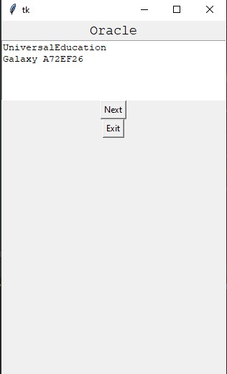

**GitHub Link: https://github.com/shettyharshita/Mobile_Computing**

**Conclusion:** The experiment was about the Mobile Node Discovery Application for check the Connection which is successfully implemented and verified.